Networking Design

Task 1
Assigning IP Addresses for the three networks and the involved devices. (For Laptop1 and Laptop2, the DHCP server will assign their IP Addresses)
Subnet Name | Subnet IP Address | First Host | Last Host | Broadcast | Subnet Mask
Network 1 | 200.111.199.0/27 | 200.111.199.1 | 200.111.199.30 | 200.111.199.31 | 255.255.255.224
Network 2 | 200.111.199.32/27 | 200.111.199.33 | 200.111.199.62 | 200.111.199.63 | 255.255.255.224
Network 3 | 200.111.199.64/27 | 200.111.199.65 | 200.111.199.94 | 200.111.199.95 | 255.255.255.224
Device | Interface | IP Address | Subnet Mask | Default Gateway
Router | Gig0/0 | 200.111.199.0/27 | 255.255.255.224 | N/A
 | Gig0/1 | 200.111.199.32/27 | 255.255.255.224 | N/A
 | Gig0/2 | 200.111.199.64/27 | 255.255.255.224 | N/A
Laptop1 | Fa0 | (DHCP) | 255.255.255.224 | 200.111.199.1
Laptop2 | Fa0 | (DHCP) | 255.255.255.224 | 200.111.199.1
DHCP Server | Fa0 | 200.111.199.66 | 255.255.255.224 | 200.111.199.65
DNS Server | Fa0 | 200.111.199.67 | 255.255.255.224 | 200.111.199.65
Email Server | Fa0 | 200.111.199.34 | 255.255.255.224 | 200.111.199.33

- My KU ID = 2121774, so the IP Address = 200.111.199.0/25.
- (2² = 4 subnets) 25 + 2 extra network bits = /27 as the new prefix
- the 27th column in the binary is 32 so our jumps = 32 which makes our second subnet 200.111.199.32/27 and our third 200.111.199.64/27
- the first host equals subnet + 1, broadcast equals next subnet -1, last host equals broadcast – 1 and, repeated this 3 times for all subnets
- prefix /27 means our subnet mask is 255.255.255.224
- the default gateways equals the first hosts of the network

Task 2
Implement the scenario in Figure 1 using Packet Tracer. Show the results of the successful implementation of this scenario

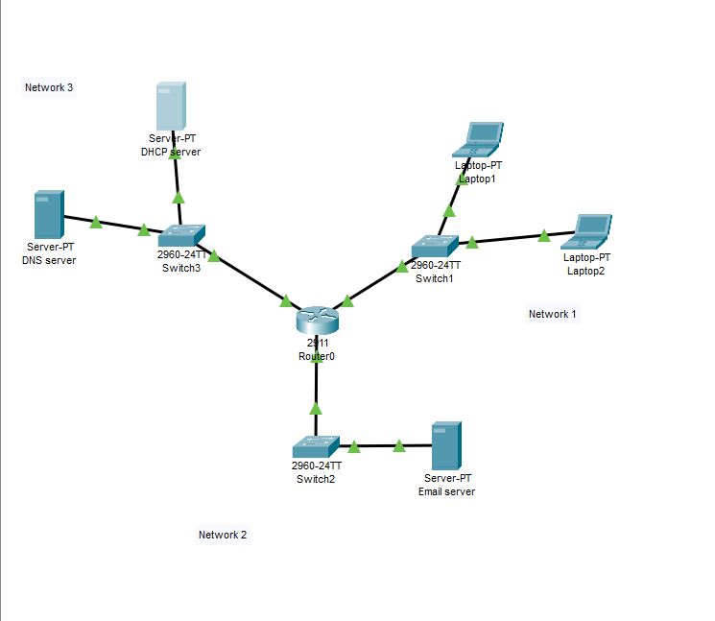
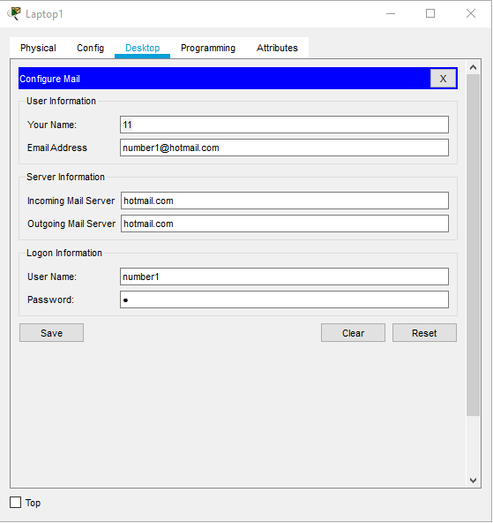
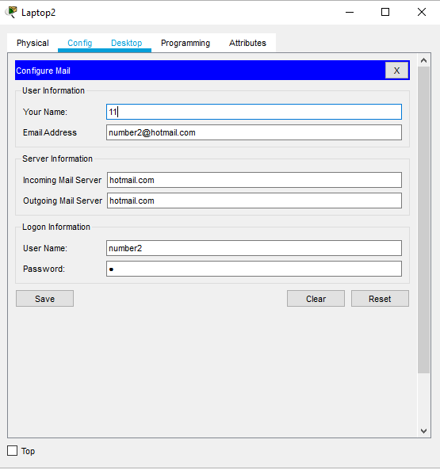

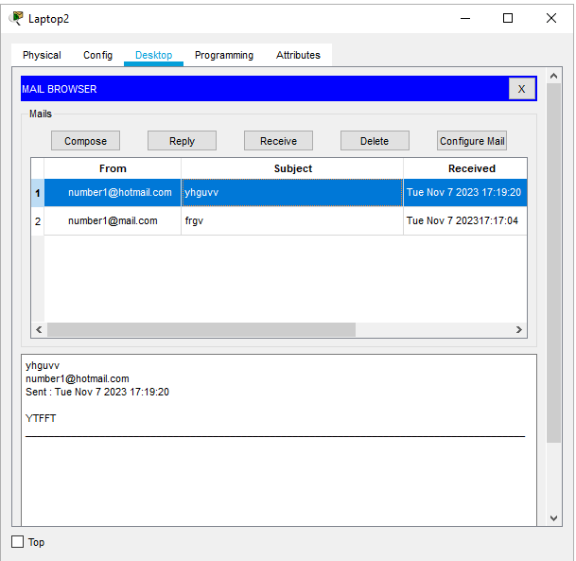
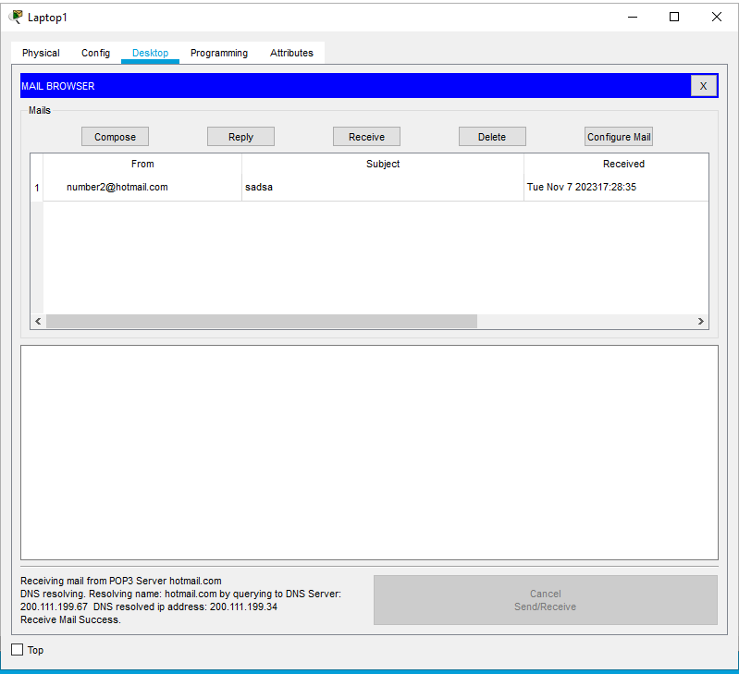
- The screenshots above are of the email account configurations number1 and number2, I composed an email from user number1 on laptop1 to number2 on laptop2

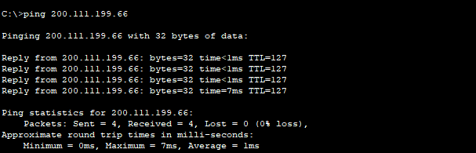
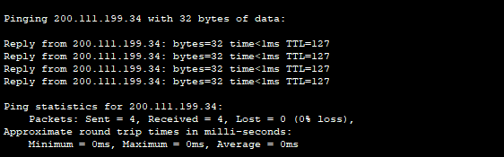
- To check successful communication between the subnetworks I pinged the DHCP server on the ip 200.111.199.66 and all the packets were received, then I pinged the Email server on the IP 200.111.199.34

Task 3
Describe the steps and protocols involved in assigning IP Addresses to the laptops in this packet tracer.
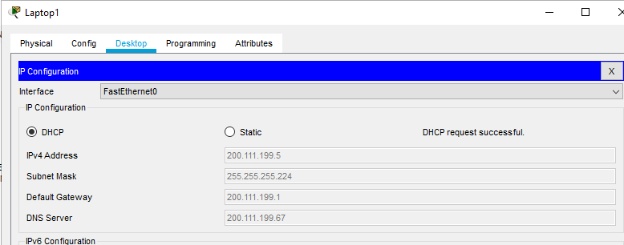
- To assign the Ips to the laptops in my Network 1, I first had to configure and assign Ips to the DNS and DHCP Server
- On the DHCP Server, I went onto the services field and created two server pools under the DHCP services section
- On the DNS Server, I went on the services field and made two DNS record for my DHCP and Hotmail.com
- On the DHCP server I added the dns ip as the DNS Server in the ip configuration and under the dhcp services field
- On the router CLI I used the IP Helper-Address configuration so that the (Gigabit Wire 0/0) connected to network 1 with the laptops are connected to the DHCP Server IP Address 200.111.199.66
- Then I went on the Laptop IP Configuration and switched it form Static to DHCP, and because of the configuration I have done, the DHCP Request was successful

Task 4
Show the steps and networking protocols involved in the emails exchange between Laptops 1 and 2 via the Email server in this packet tracer simulation.

- I set up my Email server’s IP addresses according to my IP Addressing table I did in Task 1
- Under the services section, I clicked email and turned on SMTP and POP3 Service. Then I setup two different email accounts for each of my laptops with a username and password and set up my domain name (Hotmail.com)
- On the laptops I went under the desktop and into the Email section where I configured the mail, and entered the email address, incoming mail server and outgoing mail server. And I logged the laptops into the email accounts I’ve created on the server
- Because I did the email server last, the entire network was already set up so I was able to successfully send emails from Laptop 1 and receive them on Laptop2.

